***DECLARATION BY THE CANDIDATE***

I the undersigned solemnly declare that the project report RENEWABLE ENERGY RESOURCES is based on our own work carried out during the course of our study under the supervision of MRS. SARA TABASSUM.

I assert the statements made and conclusions drawn are an outcome of my research work. I further certify that

* The work contained in the report is original and has been done by me under the general supervision of my supervisor.
* The work has not been submitted to any other Institution for any other degree/diploma/certificate.
* We have followed the guidelines provided by the University in writing the report.
* Whenever we have used materials (data, theoretical analysis, and text) from other sources, we have given due credit to them in the text of the report and giving their details in the references.

***Names:-***

1) Hasan Ali Al Idroos (160317733023)

2) Hamed Mohiuddin Rehan (160317733043)

3)Mohd. Fazaluddin(160317733027)

4) Sultan Mohiuddin(160317733049)

**I**

**ACKNOWLEDGEMENT**

We would like to express our deepest appreciation to all those who provided us the possibility to complete this report.  A special gratitude we give to our guide, MRS. SARA TABASSUM, whose contribution in stimulating suggestions and encouragement and who has invested her full effort in guiding the team in achieving the goal and also helped us to coordinate our project especially in writing this report.

Furthermore we would also like to acknowledge with much appreciation the crucial role of the staff of CSE Dept.  A special thanks goes to our team who made this possible. We have to appreciate the guidance given by other supervisor especially in our project presentation that has improved our presentation skills thanks to their comment and advices.

**ii**

**ABSTRACT**

Renewable energy is energy produced from sources that do not deplete or can be replenished within a human’s life time. The most common examples include solar, hydro, wind energy etc. Renewable energy accounts for 13.5% of the world’s total energy supply, and 22% of the world's electricity. Renewable energy systems are a major topic when discussing the globe's energy future for two main reasons:

Renewable energy systems provide energy from sources that will never deplete. Renewable energy systems produce less greenhouse gas emissions than fossil fuels energy systems.

Most renewable energy comes either directly or indirectly from the sun. Sunlight, or **Solar energy** can be used directly for heating and lighting homes and other buildings, for generating electricity, and for hot water heating, solar cooling, and a variety of commercial and industrial uses. The sun's heat also drives the **winds whose energy** is captured with wind turbines. Then, the winds and the sun's heat cause water to evaporate. When this water vapour turns into rain or snow and flows downhill into rivers or streams, its energy can be captured using **Hydroelectric power**.

iii

TABLE OF CONTENTS

Contents Page no.

Declaration I

Acknowledgement II

Abstract III

Chapter 1 Renewable Energy Resources

1.1 Introduction 1

1.2 Types Of Renewable Energy 2

1.3 Solar Energy 3

1.3.1 Advantages 4

1.3.2 Disadvantages 5

1.3.3 Examples 6

1.4 Hydro Power 7

1.4.1 Categories of Hydro Power 8

1.4.2 Advantages 9

1.4.3 Disadvantages 10

1.4.4 Examples 11

1.5 Wind Energy 12

1.5.1 Advantages 13

1.5.2 Disadvantages 14

1.5.3 Examples 15

1.6 Practical Session 16-17

1.7 Conclusion 18

1.8 Solutions 19

1.9 References 20

* 1. **INTRODUCTION**
* Renewable energy is energy produced from sources that do not deplete or can be replenished within a human’s life time. The most common examples include solar, hydro, wind energy etc.
* Renewable energy accounts for 13.5% of the world’s total energy supply, and 22% of the world's electricity. Renewable energy systems are a major topic when discussing the globe's energy future for two main reasons:
* Renewable energy systems provide energy from sources that will never deplete.
* Renewable energy systems produce less greenhouse gas emissions than fossil fuels energy systems.
* Most renewable energy comes either directly or indirectly from the sun. Sunlight, or **Solar energy** can be used directly for heating and lighting homes and other buildings, for generating electricity, and for hot water heating, solar cooling, and a variety of commercial and industrial uses. The sun's heat also drives the **winds whose energy** is captured with wind turbines. Then, the winds and the sun's heat cause water to evaporate. When this water vapour turns into rain or snow and flows downhill into rivers or streams, its energy can be captured using **Hydroelectric power**.

1

* 1. **TYPES OF RENEWABLE ENERGY**

***Solar Power***

***Hydro Power***

***Wind Power***

2

* 1. **SOLAR ENERGY**
* Solar energy is radiant light and heat from the Sun that is harnessed using a range of ever-evolving technologies.
  + Such as solar heating, photovoltaics, solar thermal energy, solar architecture, molten salt power plants and artificial photosynthesis.
  + Here are three ways solar panels benefit the environment:-
* Solar energy is radiant light and heat from sun that is harnessed using photovoltaics, solar heaters etc.
* Here are three ways solar panels benefit the environment.
* Solar energy reduces water pollution. Solar energy reduces air pollution. Solar energy reduces hazardous waste.72 percent of water pollution comes from coal-fired power plants.
* Generating energy from solar panels instead of fossil fuels can improve public health and river ecosystem.
* 31 percent of greenhouse gas emissions in US comes from electricity production. Solar energy systems can mitigate some of the damage as solar panels don't produce any greenhouse gases.
* More than 400 million tons of hazardous waste is produced every year, according to United Nations Environmental Program. Nuclear fission products, in particular, continue to be radioactive for thousands of years.

3

**1.3.1 ADVANTAGES**

* Solar power is pollution free and causes no greenhouse gases to be emitted after installation.
* Reduced dependence on foreign oil and fossil fuels.
* Virtually no maintenance as solar panels last over 30 years.
* Solar can be used to heat water, power homes and building, even power cars.

4

**1.3.2 DISADVANTAGES**

* High initial costs for material and installation.
* Needs lots of space as efficiency is not 100% yet.
* No solar power at night so there is a need for a large battery bank.
* Cloudy days do not produce much energy.

5

* + 1. **EXAMPLE**

Current is generated through Photovoltaic effect -flow of free electrons in Silicon Panel due to solar irradiance

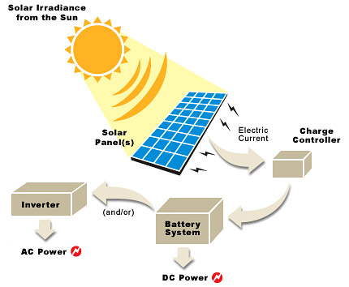

Direct current (DC) is generated which can be stored in a battery or converted to Alternating Current (AC)

6

* 1. **HYDRO POWER**
* Water energy is one of the five renewable green energy sources. The other four sources being: Wind, Solar, Biomass and Geothermal.
* Water energy or hydro-energy is divided in 3 main categories: the hydroelectric energy, tidal energy and wave energy with the last two being categorized under the category of Ocean energy.
* Water energy is divided in 3 main categories.
* They are as follows:-
* 2.(i) Tidal Energy
* 2.(ii) Hydro-Electric Energy
* 2.(iii) Wave Energy

**7**

**1.4.1 CATEGORIES OF HYDRO POWER**

***Tidal Energy***

* Tidal energy is a form of water energy, hydro-energy, which falls in the category of ocean energy.
* As the name implies it is a form of energy that converts the energy of tides into useful electric energy.

***Hydro-electric Energy***

* This is the most common and the most widely used form of renewable green energy sources.
* Hydroelectric energy has a lower cost than any other form of renewable sources and in some cases over conventional forms of energy and this gives a clear benefit to the consumer since it is free of C02 emissions.

***Wave Energy***

* Wave energy is the energy captured from the energy of ocean surface waves and that it is used to do useful work.
* Wave energy can be used not only of the production of electricity, which is its most common use, but for water pumping and water desalination as well.

**8**

**1.4.2 ADVANATGES**

* Hydropower is a fuelled by water, so it's a clean fuel source.
* Hydropower doesn't pollute the air like power plants that burn fossil fuels, such as coal or natural gas.
* Hydropower is a domestic source of energy, produced in the United States.
* Hydropower relies on the water cycle, which is driven by the sun, thus it's a renewable power source.
* Hydropower is generally available as needed; Engineers can control the flow of water through the turbines to produce electricity on demand.

9

**1.4.3 DISADVANTAGES**

* Hydropower can impact water quality and flow.  Hydropower plants  can cause low dissolved  oxygen levels in the water, a problem that is

Harmful to riparian (riverbank) habitats.

* Is addressed using various aeration techniques,  which oxygenate the water. Maintaining minimumflows of water downstream of a hydropower installation is also critical for the  survival of riparian (riverbank)habitats.
* Hydropower plants can be impacted by drought. When water is not available, the hydropower plants can't produce electricity.New hydropower facilities impact the local environment and may compete with other  uses for the land
* Those alternative uses may be more highly  valued than electricity generation. Humans, flora, and fauna may lose  their natural habitat.

10

**1.4.4 EXAMPLE**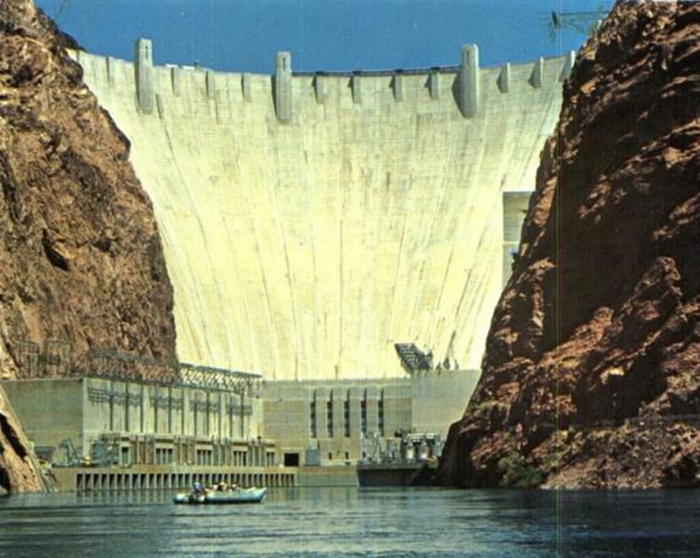

HOOVER DAM

**11**

**1.5 WIND ENERGY**

* Wind power converts the kinetic energy in wind to generate electricity or mechanical power.
* This is done by using a large wind turbine usually consisting of propellers; the turbine can be connected to a generator to generate electricity, or the wind used as mechanical power
* Wind is converted by the blades of wind turbines
* To create electricity from wind the shaft of the turbine must be connected to a generator.
* The generator uses the turning motion of the shaft to rotate a rotor which has oppositely charge magnets and is surrounded by copper wire loops.
* Electromagnetic induction is created by the rotor spinning around the inside of the core, generating electricity

12

**1.5.1 ADVANTAGES**

* **Industrial and Domestic Installation:** – Wind turbines can be built on existing farms or ranches where most of the best wind sites are found.
* **Clean & Environment friendly Fuel source:** – It doesn’t pollute air like power plant relying on combustion of fossil fuel.
* **Renewable & Sustainable:** – Winds are caused by heating of atmosphere by the sun, earth surface irregularities and the rotation of the earth.
* **Job Creation:**– Jobs have been created for the manufacture of wind turbines, the installation and maintenance of wind turbines and also in wind energy consulting

13

**1.5.2 DISADVANTAGES**

* Fluctuation of Wind and Good wind sites: – Wind energy has a drawback that it is not a constant energy source. Although wind energy is sustainable and will never run out, the wind isn’t always blowing.
* Noise and aesthetic pollution: – Wind turbines generate noise and visual pollution. A single wind turbine can be heard from hundreds of meters away. Although steps are often taken to site wind turbines away from dwellings.
* Not a profitable use of land: – Alternative uses for the land might be more highly valued than electricity generation.
* Threat to wildlife: – Birds have been killed by flying into spinning turbine blades.

14

**1.5.3 EXAMPLE**

**GENERATION OF ELECTRICITY FROM WIND TURBINES**

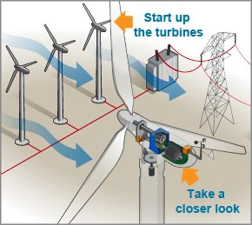

15

* 1. **PRACTICAL SESSION**

16

We have carried out the following practical session of solar cell. We have observed that the amount of sunlight as determined by the climate of one's location and the ability to receive the direct rays of the sun helps one to decide if the panel works. And when the above principle of solar energy i.e. if The Sun’s rays strikes the panel the heat is absorbed and is converted into electrical energy and thus gives the result. And this Energy is quite efficient.

17

**1.7 CONCLUSION**

* Finally we can conclude that we are on peak of using our energy resources and this is very much clear from previous discussions that our non-renewable resources are on a peak of their use and one day ultimately they will vanish of their existence from world.
* Main benefit of renewable energy is that it is clean form of energy and also socially acceptable and help government to make a dream true to provide electricity to the village.
* So we need to develop our renewable energy resources more and more if we want to enjoy a peaceful and satisfactory life in today’s energy hungry world.

18

**1.8 SOLUTIONS**

* Improve energy efficiency
* Increase local availability of renewable energy resources
* Find transitional resources (natural gas, nuclear)
* Government must promote R&D for alternative renewable energy resources.
* Educate the public
* All energy resources should compete in an open, free-market with NO government control!
* Government needs to implement constructive subsidies not destructive subsidies to promote change, this will lead to ***conservation of resources and less over-consumption.***

19

**1.9 REFERENCES**

[https://en.wikipedia.org/wiki/Renewable_energy.](https://www.eia.gov/energyexplained/?page=renewable_home)

[https://www.eia.gov/energyexplained/?page=renewabl home](https://www.eia.gov/energyexplained/?page=renewabl%20home)

20